**DAILY ONLINE ACTIVITIES SUMMARY**

|  |  |  |  |  |  |  |  |  |
| --- | --- | --- | --- | --- | --- | --- | --- | --- |
| **Date:** | **22-05-2020** | | | | | **Name:** | **Raksha S** | |
| **Sem & Sec** | **6th B** | | | | | **USN:** | **4AL17CS073** | |
| **Online Test Summary** | | | | | | | | |
| **Subject** | | **Operation Research(OR)** | | | | | | |
| **Max. Marks** | | **30** | | **Score** | | | **30** | |
| **Certification Course Summary** | | | | | | | | |
| **Course** | **FullStack Webdevelopment & CyberSecurity Specialisation** | | | | | | | |
| **Certificate Provider** | | | **Greatlearning**  **udemy** | | **Duration** | | | **45days**  **40days** |
| **Coding Challenges** | | | | | | | | |
| Problem Statement: 1. Write a C Program to implement various operations of Singly Linked List Stack  2. Write a Java Program to find the largest and smallest word in a string. | | | | | | | | |
| **Status:** YES, Completed all Programs | | | | | | | | |
| **Uploaded the report in Github** | | | | | **YES** | | | |
| **If yes Repository name** | | | | | https://github.com/raksha05/[Daily-Status](https://github.com/raksha05/Daily-Status)/[Raksha 4AL17CS073](https://github.com/raksha05/Daily-Status/tree/master/Raksha%204AL17CS073)/**Raksha** | | | |
| **Uploaded the report in slack** | | | | | **YES** | | | |

Online Test Details:

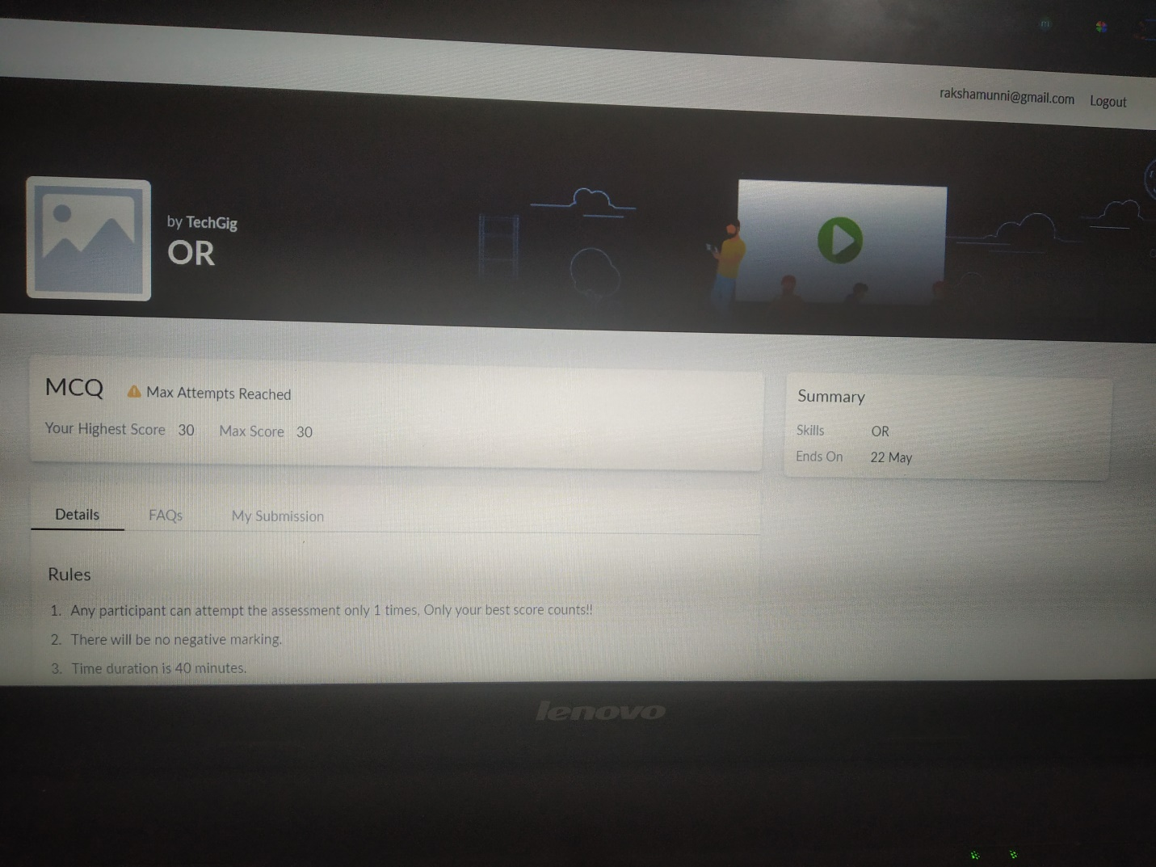

Scored 30 out of 30 in OR 1st I.A test

Certification Course Details:

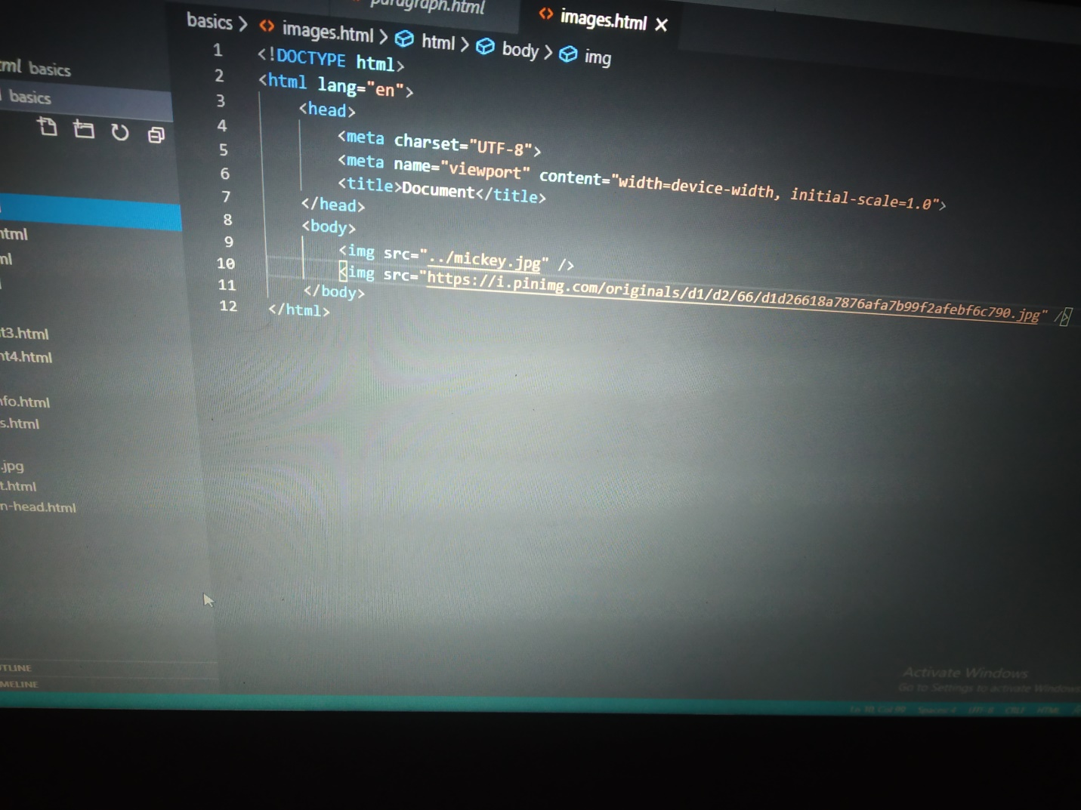

The above course is being taken up by me is based on FullStack Webdevelopment. It started with the html tags, today in online course I studied about how to connect a webpage from parent folder as relative and absolute path by ../ and add image to website from the system or through access the link directly through internet by using img tag.

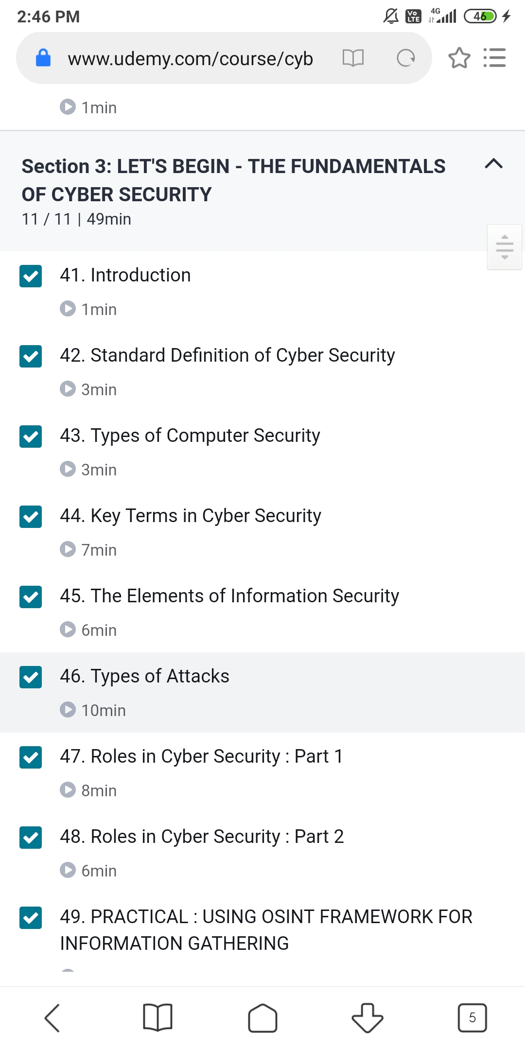

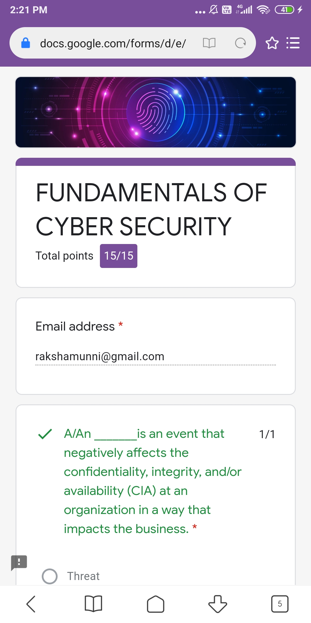

The above course is taken by me is based on CyberSecurity Soecialisation.It started from basics of networking,fundamental of cyber security.Today I learnt types of computer security,osint frameworks,key terms and types of attacks.Wherein assignment quiz was taken up where I scored 15 out of 15.

Coding Challenges Details:

Program1:

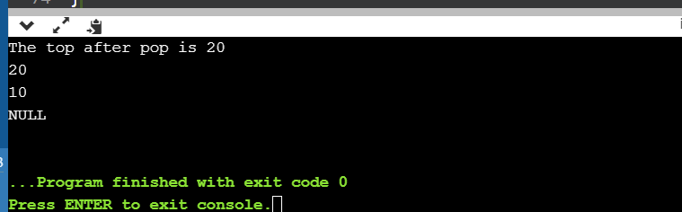

Program2:

